GATOR S1

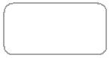

User Manual V1.1

2020.02

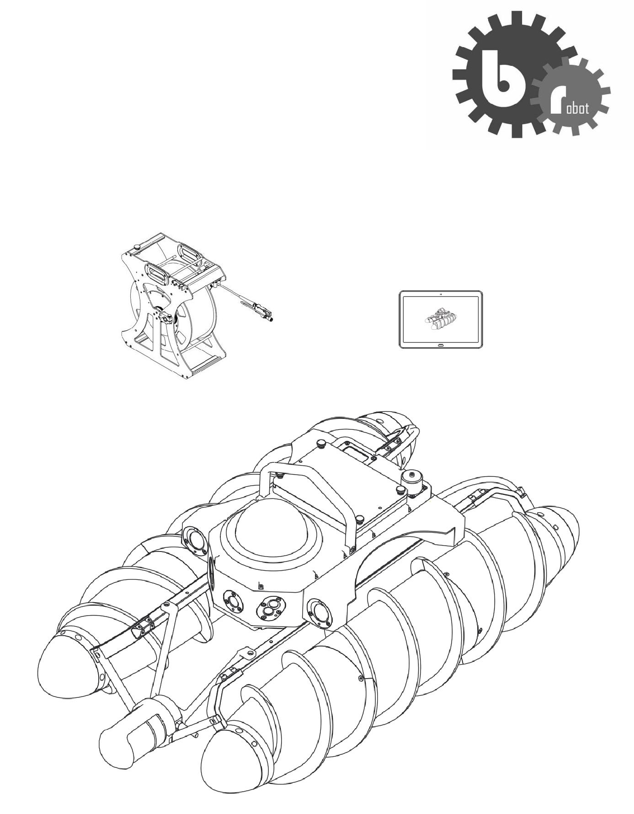

**Contents**

1.**Product description**

Introduction

Feature highlights

System composition

1. **Crawler**

Crawler components

Characteristics

Control method

1. **Cable car**

Cable car components

Cable car operation

1. **Controller software**

Overview

Functions

1. **5.Operation**

Application

Device connection

Operation

**6.Precautions**

Operation Precautions

Safety Precautions

**7.Appendix**

Specifications

**1.Product description**



Introduction

Gator S1 pipeline inspection all-terrain CCTV is the world's first new pipeline inspection equipment. Using the spiral propulsion structure, GATOR-S1 can meet all-terrain requirements such as working at the water body, shallow cement beaches, and sandy beaches, etc. where traditional CCTV robots cannot be applied. When it works in pipes with water, the sonar probe, carrying by the Gator S1, inspects the underwater structural defects in the pipe.

Feature highlights

3 million pixels front and 3 million pixels rear camera to assist robot control; 360° horizontal rotation and 90 °pitch of the 2 million PTZ camera displaying a comprehensive view of the interior of the pipeline.

The pipe robot is light and flexible; suitable for pipelines and tanks with a diameter over 600mm, dark river culverts, and river shoals.

2 replaceable batteries. One single battery supports 2 hours’ working time.

Equipped sonar probes , the device detects the underwater structural defects in pipelines.

Handheld controller provides simple and light operation; match up with the hand-grip controller

Standard configuration: 300m cable; 500m and 1000m cable also available.

Automatic retractable cable matching with the running speed of the crawler that improves inspection efficiency

The controller software superimposes and collects a variety of data information at the same time, and quickly generate comprehensive report file.

Main Components

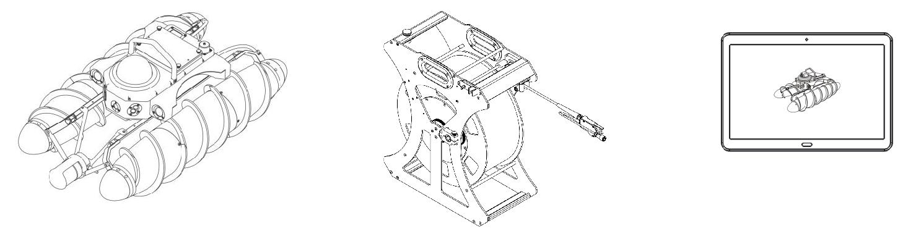

Crawler Cable car Controller

Gator S1 all-terrain CCTV is consists of crawler, cable car, and the smart controller. The wireless connection between the hand-held controller and the cable car is easy for operation; cable car and crawler are connected by buoyant cable; the cable tensile strength is 50KG; controller software remotely controls the crawler working in the pipeline.

Crawler



Crawler components

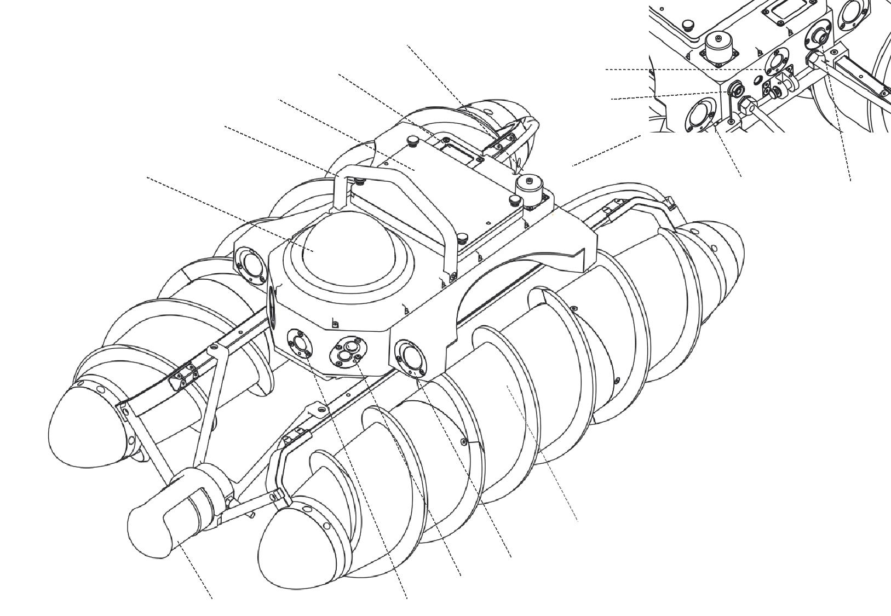

|  |  |  |
| --- | --- | --- |
| 4 | 5 |  |
| 6 |  |
| 3 | 7 |  |

|  |  |  |  |
| --- | --- | --- | --- |
|  | 2 |  |  |
| 1 | 8 | 9 |  |
|  |  |
|  |  |  |

|  |  |  |  |  |
| --- | --- | --- | --- | --- |
|  |  |  | 10 |  |
|  | 12 | 11 |  |  |
|  |  |  |  |
| 14 | 13 |  |  |  |

[1] PTZ camera [6] Rear camera [11] Front headlight

[2] Handle [7] Sonar socket [12] Side headlights

[3] Battery [8] Rear headlights [13] Front camera

[4] Laser ranging [9] Cable socket [14] Sonar (optional)

[5] Power switch [10] Spiral wheel

Movement features

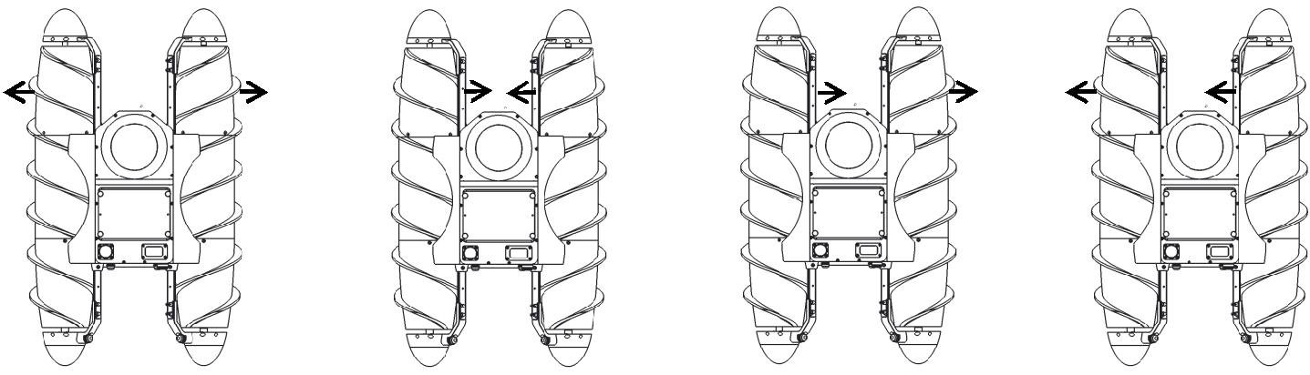

Forward Backward Turn left/ Shift right Turn right/ Shift left

Forward: Left and right wheel spins rotate reverse outward

Backward: the left and right wheels rotate reverse inward

Turn left / shift right: when working on the soft mud, water, or sand, the left and the right wheels rotate to the right direction and the left turn effect will happen; when working on the hard road, the left and right wheels rotating to the right, the wheel teeth lose its function and the whole device will move to the right..

Turn left / shift right: when working on the soft mud, water, or sand, the left and the right wheels rotate to the left direction and the right turn effect will happen; when working on the hard road, the left and right wheels rotating to the left, the wheel teeth lose its function and the whole device will move to the left.

Control method

The left and right wheels are set with independent differential speeds. The operator uses the disc point of controller software to control the robot. When the disc point stays in the center, it indicates the robot is stationary. Pushing up the disc point will control the robot to move forward. When the disc point is away from the center, it indicates the left and right spiral wheels rotate. The further the disc point is away from the center the faster the wheels rotate, and the faster the robot moves forward.

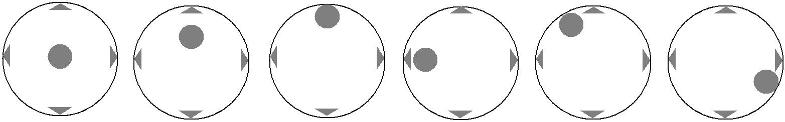

Still Half speed Full speed Turn left in place at a certain speed Full speed left-turn forward Full speed right-turn backward

The above six icons illustrate the flexibility of the disc point operation that adjusts the speed and direction during the robot moving.

Cable car



Cable car components

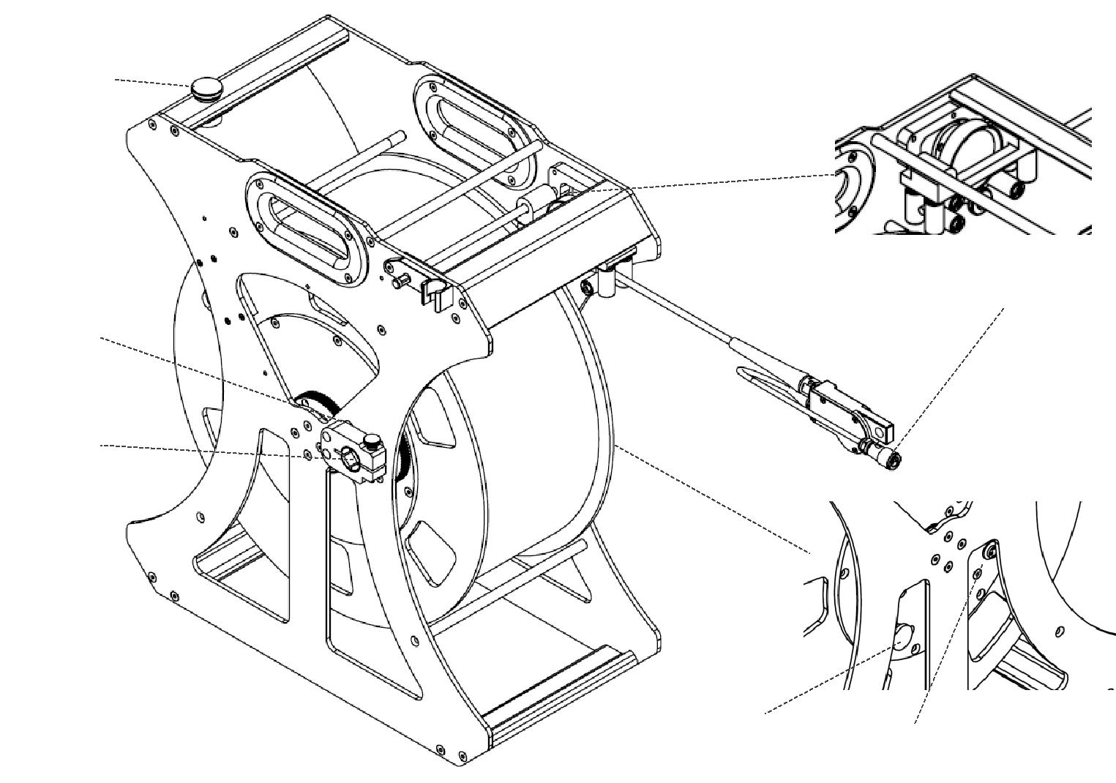

1 2 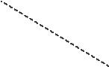

3

7

6

[1] Retractable cable switch [4] Power switch [7] Cable tensioner

[2] Meter counter and wiring device [5] Charging interface

[3] Aerial plug [6] Manual cable retracting handle socket

Cable car operation

Cable releasing: when the robot moves forward, the operator needs to manually pull out and slowly release the cable matching with the running speed of the crawler

Cable retracting: when the robot moves backward, please avoid the cable drawn into the spiral wheel. Keep the cable straight at the tail of the robot. When moving backward, the operator needs to pull back the cable manually or press the electric retractable cable button on the cable car to retract the cable.

Cable adjusting: when retracting the cable, please pay attention to the cable reel and the situation of wire wrapping. The operator needs to manually move the cable to left or right to adjust the cable evenly.

Tight the cable reel: During transportation or charging, please properly clamp the elastic block to prevent the cable reel from rotating.

Charging: The charging interface is on the side of the cable reel. Rotate the cable reel so that the charging port stays in the proper place, clamp the elastic block, and connect the charging aerial plug to charge the cable car.

Controller software



Controller software introduction

With simple and easy-to-use controller software, the hand-held controller wirelessly connects to the cable car to operate the robot remotely. The functions of controller software including image display, battery power, attitude data display, etc., also integrate project information editing, video recording, snapshot, and simple report generation such standard functions in the CCTV pipeline inspection.

Functions instruction



|  |  |  |  |  |  |  |  |
| --- | --- | --- | --- | --- | --- | --- | --- |
| 17 | 18 | 19 20 21 | 22 23 24 | 25 | 26 | 27 |  |
| 16 |  |  |  |  |  | 1 |  |
| 15 |  |  |  |  |  |  |
|  |  |  |  |  |  |  |
| 14 |  |  |  |  |  | 2 |  |
| 13 |  |  |  |  |  |  |
|  |  |  |  |  |  |  |
| 12 |  |  |  |  |  | 3 |  |
|  |  |  |  |  |  |  |
| 11 |  |  |  |  |  |  |  |
| 10 |  |  |  |  |  | 4 |  |
| 9 |  |  |  |  |  |  |
|  |  |  |  |  |  |  |

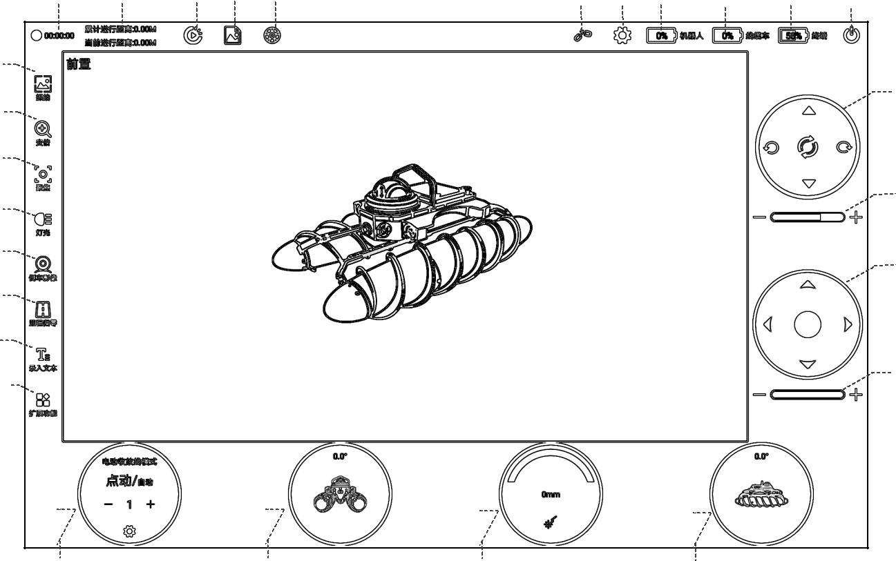

|  |  |  |  |
| --- | --- | --- | --- |
| 8 | 7 | 6 | 5 |

[1] PTZ motion control panel [10] Project information input [19] Video playback

[2] Adjust the speed of PTZ movement [11] Zero mileage compensation and compensation [20] Photo preview

[3] Crawler control panel [12] Turn on the front and rear camera [21] Control prohibited

[4] Crawler maximum speed adjustment [13] Light adjustment [22] Device connection status

[5] Crawler pitch angle [14] Camera focus adjustment [23] Other function settings

[6] Laser ranging [15] Camera zoom adjustment [24] Crawler power

[7] Crawler roll angle [16] Image capture [25] Cable car power

[8] Electric retractable cable control [17] Recording time [26] Controller power

[9] Extended functions [18] Meter counter display [27] Software exit

Operation



Applications

For DN600 pipes, it requires at least 1/3 of water or sediment deposits at the bottom. However, once water or sediment deposits exceed 1/2 of the pipe diameter, all-terrain robots are no longer applicable. For DN800 pipelines, it requires at least 1/4 of water or sediment deposits at the bottom. However, when water or sediment deposits exceed 3/4 of the pipe diameter, all-terrain robots are no longer applicable. For box culverts, culverts, etc., it needs to be at least 50mm to 100mm of water or sediment at the bottom. If sonar is required, the water depth needs to be more than 300mm, and the maximum width cannot exceed 6m so that the data detected by the sonar is optimal. Secondly, for the inspection in a pipeline or box culvert with water flow, try to choose downstream inspection as far as possible to achieve the best results. If the counter current is selected, the speed of water flow cannot exceed 0.4m / s.

Device connection

All-terrain robot adopts the tailored floating cables with a standard length of 300 meters (500-meter and 1000-meter cable also available). During the operation, the operator should avoid to bend the cable at zero angles, and the cable bending radius must be more than 10mm. It is necessary to keep the plug clean where at the end of the cable and keep the socket clean where at the end of the crawler. After each operation, keep the tal plug part clean to prevent impurities such as mud and water entering the rear socket of the crawler.

Diagram of tail aviation plug

[1] Cable [2] Tail rubber sleeve [3] Cable board [4] Cable end [5] Aviation plug

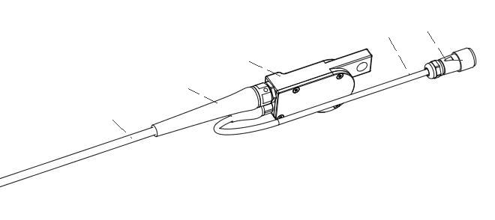

4 5

3

2

1

Device connection diagram

**[3]**

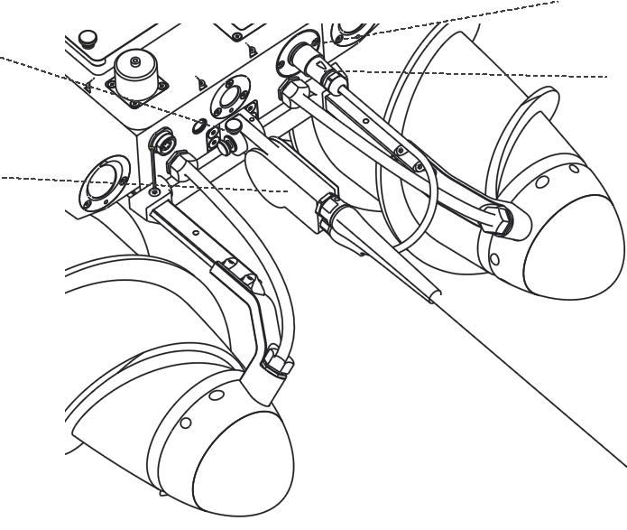

[2]

**[4]**

[1]

[1]Pull plate [2] Hand screw [3] Cable socket [4] Aviation plug

The connection of cable and crawler is in two steps:

1. Connect the [1] cable board on the cable car to the crawler and tighten the thumbscrew [2];

2. After align [4] aerial plug with [3] cable aerial socket and plug it in, the connection is complete.

After completing the connection between the cable car and the crawler, turn on the power of the cable car and the crawler. After the WIFI on the device appears, connect the cable car with the controller. Observe the “device connection status” in the controller software and confirm the cable properly connected to the crawler.

Operation tips

1. In the DN600 pipeline, when there is only a small amount of silt or other sediments at the bottom of the pipeline, the operator must adjust the crawler speed to less than 1/3 of the normal speed, and pass the pipe slowly, otherwise, the crawler is prone to rollover;

2. Encountering a hard obstacle, adjust the speed to less than 1/3 of the normal speed, and operate with caution. If necessary, use the backward pulling force of cable to retreat and avoid the obstacle;

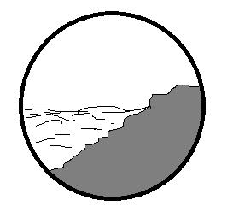3. Operation tips for the following situations:

1)When there is sediment on the right side and water on the left side of pipe or box culvert, and the width of the water surface just allows the crawler to pass, the user need to consider following points:

a. Whether the crawler can be lifted out of from the next manhole;

b. Whether there is water flowing in the current pipeline and whether the user can raise the water level after this pipe section being blocked; If the next manhole can be opened, please reduce the speed of the crawler and pass slowly; if it cannot be opened, it is not recommended to drive the crawler to pass this pipe section, because the crawler will get stuck. If the crawler is stuck, consider blocking the manhole to allow the water level to rise to retrieve the crawler.

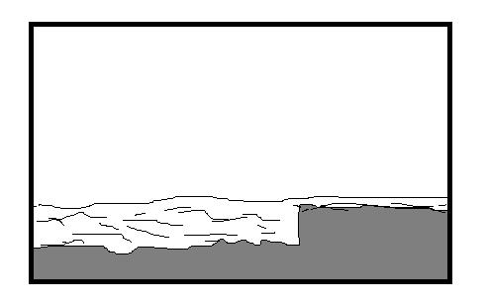

2) When in the pipeline or box culvert, there is a step in the underwater sediment, and the water depth is less than the diameter of the spiral wheel of the crawler. It is recommended to get around the step to avoid the crawler tilting or rollover;

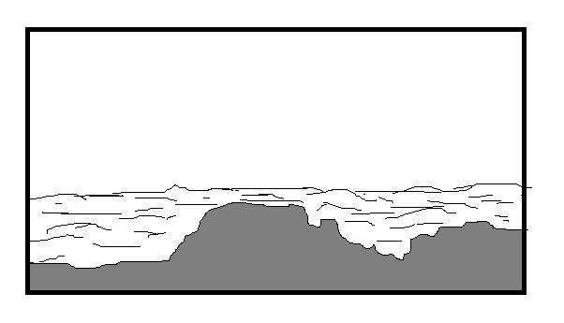

3) When the crawler goes through the pipeline with underwater sediments that are not silt, sand, etc. but the hard stones, the crawler will shake and the direction control is not very smoothly. At this time, please reduce the speed, and try to move forward from the place the water as deep as possible.

4) For the pipeline inspection, it is recommended to choose the downstream direction because the crawler can pass the pipe smoothly. However, the downstream flow speed should not exceed 1m / s, and it is not advised to do the pipeline inspections with the high flow speed. If the user needs to inspect the pipe with reverse flow, the advised flow speed should not exceed 0.2m / s.

3. Two operators are required for the general operation, one operating the controller and the other control the cable releasing and retracting. When the crawler is moving forward and backward, the cable should be properly tensioned. When moving forward, the user needs to release the length of the cable to match the distance of the crawler. When moving backward, avoid the cable from being caught in the spiral wheel. Therefore, the two operators need to work closely together.

4. During operation, please pay attention to the battery power. When the battery power is close to 5%, the battery needs to be replaced.

5. When the crawler is working in the pipeline, avoid some band-shaped debris as much as possible, and after each time the crawler is lifted out, the debris wrapped around the spiral wheel needs to be cleaned thoroughly.

6. After each operation, the equipment needs to be cleaned and maintained, especially for the cable plug part, it needs to be carefully cleaned to prevent foreign objects from entering the plug.

**Precautions**



Operation Precautions

1. Do not lift the robot directly with the cable, please put robot in or out of the manhole with two ropes;

2. Pay attention to the cleanliness of the robot's aerial plug connection to prevent small particles such as sediment and moisture from entering the aerial plug;

3. When replacing the battery, keep the battery surrounding area clean. When placing the battery, pay attention to the position of the waterproof seal;

4. Pay attention to the cleanness of the switch cap to prevent small particles from entering the switch and affect the waterproof ; if the seal ring at the switch is damaged, please replace it before using the robot;

5. The spiral wheel needs regular maintenance (such as once one month). According to the instruction of “GatorS1 Robot Spiral Wheel Maintenance”, check if the water is inside the wheels and do maintenance on the wheels according to the above instruction.

6. Do not to pull the cable end at any time;

7. When retreating the robot, turn on the rear camera and observe the cable to prevent it from getting caught in the roller.

8. If sonar is selected, please read “Precautions for Using Sonar” carefully.

Safety Precautions

1. When operating, carrying and cleaning the crawler, please pay attention to your hands and be careful not to be scratched by the roller pinch;

2. When carrying the cable car, please pay attention to your legs and feet, and be careful not to be injured by the equipment.

3. During the device operation, be careful not to be tripped over the cables;

4. When charging the device, pay attention to the electricity safety, and avoid the operations such as retracting and unwinding, rotating the cable reel, etc.

Appendix



Specifications

Pipe Robot (Model: Gator-S1)

Weight 12.5Kg( Including one battery)

Size: 760*460*325mm(without Sonar)，825*460*325mm(with Sonar)

Applicable pipe diameter: ≥DN600

Protection class: IP68

Speed: Static water speed 0.3m / s, sand speed 0.6m / s

Steering: in site steering 360°

Life time: 2h (one battery)

Battery charging time: 3.5h

Camera

Front camera: 3 million pixels

Rear camera: 3 million pixels

PTZ Camera: 2.8-12mm focal length, 4x optical zoom, 2 million pixels, 1920 * 1080p resolution,

The horizontal rotation angle is 0-359 degrees, and the pitch angle is 0-90 degrees.

Cable car

Weight 20Kg

Size 450*510*235mm

Cable length Standard 300m , optional 500m and 1000m

Power supply Built-in battery, capacity 14.5Ah，life time 6-8h

Cable retract Electric power supply

Communication WIFI

Controller

Weight 465g

Size 248*173*7.8mm

Data storage 64G

Working time 8hrs

Interface Type-C compatible mobile phone interface and charger

Sonar probe

Material:  6061-T6 aluminum and polyurethane

Frequency: not less than 2.25MHz

Applicable pipe diameter: 100-6000mm

Protection class: IP68, maximum underwater depth is not less than 1000m

Pulse width: The emission pulse width is not less than 4~20us

Working temperature: not less than 0-40

Storage temperature: not less than -20~70°C